LEGACY UNITED METHODIST CHURCH

PERSONNEL POLICY MANUAL

REVISED AUGUST 2020

TABLE OF CONTENTS

Introduction 2

Miscellaneous Employment Provisions
Federal and State Law 3
Non-Discrimination 3
Nepotism 3
Outside Employment 3
Confidentiality 3
Grievance Policy 3

Employment Process
Position Description 4
Requisition 4
Recruitment 4
Application 4
Selection 4
Confirmation 4
Record Retention 4

Employment Status
Classification 5
Evaluation 5
Promotion 5
Separation 5

Salary Administration
New Hire Schedule 6
Current Employees 6
Meritorious Awards 6
Longevity Awards 6
Pay Distribution 6

Time and Attendance
Church / Work Schedules 7
Recording Time Worked 7
Excess hours Worked 7
Meals and Rest Periods 7
Leave of Absence 7

Paid Time Off
Holiday 8
Annual Leave 8
Sick Leave 8
Bereavement Leave 8
Jury Duty 8

Employee Conduct
Personal Appearance 9
Personal Activity 9
Social Media 9
Employment Harassment 9
Corrective / Disciplinary Action 9

Appendices:
A: Mission Statement 10
B: Position Description 11
C: Job Vacancy Announcement 12
D: Application 13
E: Timesheet 15

INTRODUCTION

Legacy United Methodist Church (LUMC) employs qualified personnel dedicated to achieving the Legacy vision while exemplifying Christian living on a daily basis. Employees are the foundation of and reason for success at LUMC, and as such, are valued, trusted, and respected. It is necessary to maintain a mutually beneficial employer – employee relationship at all times. Information contained in this document provides a guide to assure such outcome.
The Administrative Team, through its’ Staff Parish Relations Committee (SPRC), is responsible for all employee matters at LUMC. They have developed policies governing the recruitment, selection, retention, compensation, and separation, as well as all other personnel issues, of LUMC employees. The policies in this document will be reviewed annually at a minimum, but may be revised on an as needed basis.
The Administrative Team has entrusted oversight of personnel matters to the Executive Pastor. Although the Executive Pastor may exercise minor discretion in administration of these policies, every effort will be made to observe consistent application.
In the event an item is not addressed by this document, the Executive Pastor will consult with the Lead Pastor prior to final decision. If there is uncertainty or disagreement between the Executive Pastor and the Lead Pastor, the item will be discussed with the SPRC. Once a decision is final, this document will be revised accordingly to reflect the impact of the decision and all revisions will be documented for the annual review.
Keeping in mind the primary purpose of LUMC is to worship, serve, and learn about Jesus Christ, all employees are expected to conduct themselves in accordance with the vision, mission, strategy, and method of LUMC. Please refer to the Mission Statement Documentation (Appendix A) for details.

MISCELLANEOUS EMPLOYMENT PROVISIONS

Federal and State Law:
LUMC will abide by all applicable federal and state employment law.

Non-Discrimination:
LUMC is an equal opportunity employer and will not discriminate in any circumstance against an applicant or employee on the basis of race, color, religion, sex, age, national origin, disability, or marital status.

Nepotism:
LUMC recognizes that employment of relatives and favoritism that may be shown relatives has the potential to create conflict of interest. The Administrative Team will review any potential nepotism issue on a case by case basis prior to employment. This policy does not apply to employees appointed by the Dakotas Conference or when an urgent short-term need arises.

Outside Employment:
LUMC employees may engage in employment outside the church as long as said employment does not interfere with church duties nor is it in direct conflict with essential business related interests of LUMC.

Confidentiality:
Due to the personal nature of LUMC, confidentiality is of the utmost concern. All employees are expected to maintain this critical portion of employment. Breach of this trust could be cause for termination.

Grievance Policy:
Employees having concerns about working conditions, interpretation of policy and procedures, disciplinary action or other matters related to employment, shall submit a written grievance to the Executive Pastor or the SPRC (depending on the grievance subject matter). If the concern cannot be satisfactorily resolved, the employee will present the concern to the Administrative Team. The decision of the Administrative Team is final.

Non – Contract:
This document does not constitute a contract between LUMC and any employee of LUMC.

EMPLOYMENT PROCESS

Position Description:
Every position requires a current job description. Whenever a vacancy exists, the applicable job description should be updated to meet current needs of LUMC. Job descriptions should be reviewed annually and adjusted as needed to reflect current duties and responsibilities. The SPRC must approve new or revised job descriptions as they occur. Please refer to the Position Description Documentation (Appendix B) for details.

Requisition:
All employment requests must be authorized by the LUMC Administrative Team whether filling a vacant position or creating a new position. In the event an emergency exists, the Executive Pastor may employ temporary assistance or procure independent contractors until the position is properly filled.

Recruitment:
When a position becomes vacant, LUMC will determine the best way to fill the position. Depending on the requirements of the position, this may range from an internal recommendation to an external announcement and search. The Executive Pastor and the SPRC will determine the appropriate notification process. Please refer to the Job Vacancy Announcement Documentation (Appendix C) for details.

Application:
All applicants must complete an LUMC employment application form including any additional required information for the specific position. The Executive Pastor or appropriate designee will review applicants and recommend to the SPRC qualified candidates for interview. Please refer to the Application Documentation (Appendix D) for details.

Selection:
The Executive Pastor and the SPRC will appoint a selection committee to interview the applicants. The selection committee will prepare an interview questionnaire / selection criteria document to conduct the interview. Upon completion of interviews, the selection committee will choose a successful candidate or choose to expand the process as necessary to fill the position as desired.

Confirmation:
The Executive Pastor or appropriate designee will conduct reference and background checks on the successful candidate. If such checks provide favorable results, the successful candidate will be presented to the Administrative Team for approval.

Record Retention:
LUMC will maintain a confidential personnel file for each employee. The file will include such items as application, resume, reference letters, job description, employer-employee correspondence, and any other pertinent employee documentation. Only the Executive Pastor and / or the employee may access the file at any time. Both the Executive Pastor and the employee must be present to add anything to the file.

EMPLOYMENT STATUS

Classification:
LUMC employees are classified as follows:
Conference Appointee – not employed directly by the church (policy exceptions apply)
Church Employee – employed directly by church (all policies apply)
Full-time – scheduled to work 40 hours per week
Part-time – scheduled to work between 20 and 40 hours per week
Intermittent – scheduled to work less than 20 hours per week
Temporary – fills a position expected to be short term or seasonal in nature

Evaluation:
LUMC does not conduct formal employee evaluations. Instead, LUMC subscribes to an ongoing long-term employer / employee career plan process. This process includes:
Mutually developed professional and personal annual goals
Access to adequate resources to achieve goals
Periodic review to assess and assure goal progress
Annual evaluation of goal success

Promotion:
LUMC will work with employees to continually try to progress professionally and improve employment knowledge and skills. LUMC will make every effort to provide professional growth and development opportunities, increase responsibility levels, and prepare employees for further career development. Such employee enhancement may lead to position reevaluation and reclassification where deemed appropriate.

Separation:
Voluntary separation is based on the employee’s choice to resign employment. Employees are asked to provide a two week notice, if possible, when voluntarily leaving LUMC employment.
Involuntary separation is based on LUMC’s choice to terminate employment. Termination occurs when the employee fails to satisfactorily function in accordance with the employee’s job description, the employee disregards LUMC policies and procedures, or in the event the position can no longer be funded. LUMC will notify the employee in writing of such cause of action.
Upon separation, all employees are required to return church property such as keys, credit cards, etc. prior to receiving a final paycheck.

SALARY ADMINISTRATION

New Hire Compensation Schedule:
A target value will be established for each position based on prior employee pay, duties, market, etc. Newly hired individuals will be placed on a sliding schedule from step 1 to step 5 based on education, experience, etc. as it relates to the target value. Each year thereafter, the target value will be increased by the general salary percentage increase provided to all staff. The succeeding year step percentage will then be applied to the new target value annually until the target value is reached.
Target Value 100%
Step 5 97%
Step 4 94%
Step 3 91%
Step 2 88%
Step 1 85%

Current Employees Compensation Schedule:
The SPRC will recommend salary increases for current staff based on economic and financial conditions. Market analysis reviews may be conducted if deemed necessary. All increases are subject to Administrative Team approval. Increases may be given as follows:
General compensation – percentage given to each employee
Step progression – given to employees on target value table
Reclassification – given to employees with significant increase in responsibility or duties

Meritorious Awards:
Merit awards for exceptional service may be given in bonus form. Such increases are rare in nature and should be used sparingly.

Longevity Awards:
Longevity awards will be given at the completion of every five year service period in bonus form. Each five year award will increase in value at the discretion of the Administrative Team.

Pay Distribution:
Direct deposit payroll will be issued on the fifteenth and last day of each month. If either day falls on a weekend or an observed holiday, payroll will be issued last working day prior to the regular payday.

TIME AND ATTENDANCE

Church / Work Schedules:
LUMC maintains a regular office schedule from 9:00 am to 3:00 pm Monday through Friday. Exceptions to this schedule are closings for any observed holiday. Additional exceptions may occur due to emergency or inclement weather.
Employee work schedules vary greatly depending on position. All employees should inform the Communications Director of their planned schedule for informational purposes.

Recording Time Worked:
All employees except for the Pastor(s) are required to maintain a record of their time worked and leave taken. Time records should be submitted to the Executive Pastor monthly. Please refer to Timesheet Documentation (Appendix E) for details.

Excess Hours Worked:
Salaried employees are professional or administrative in nature and are not subject to overtime provisions. However, salaried employees may record hours in excess of their scheduled hours and bank them for use at a later date.
Hourly employees are subject to overtime provisions. Overtime at the rate of 1.5 times the employee hourly rate will be paid for any hours worked exceeding 40 hours in a standard workweek. Employees should seek approval of overtime prior to working excess hours. For purposes of calculating overtime, the workweek begins Sunday at 12:00 am and ends Saturday at 11:59 pm.

Meal and Rest Periods:
Employees are allowed a minimum of a 30 minute unpaid meal break if they are scheduled to work more than 5 consecutive hours.
Employees are allowed a 15 minute paid rest period for each consecutive 4 hour period worked.

Leave of Absence:
Any employee may request an extended leave of absence. The request must be made in writing to the Administrative Team for approval / denial.
LUMC will comply with all legally required leave requests if all legal requirements are met.
If the leave of absence is not legally required, the employee is expected to meet with the SPRC to explain the nature and need of the requested absence. Each request of this type will be viewed on a case by case basis to determine the best interest of LUMC.
Leave of absence may be paid if the employee has sufficient annual leave time available and chooses to apply it to the leave.

PAID TIME OFF

Holidays:
Full-time employees receive 9 paid holidays. Part-time employees receive pro rata holidays.
New Year’s Day Easter Monday Memorial Day
Independence Day Labor Day Thanksgiving Day
Thanksgiving Friday Christmas Day Flex Days (2)
Saturday holidays are observed Friday; Sunday holidays are observed Monday. Occasionally, the Executive Pastor may allow discretionary observance of holidays based on church schedules and events.

Annual Leave:
Full-time employees receive annual leave below. Part-time employees receive pro rata leave.
Years 0 - 5 8 hours per month (12 days per year)
Years 6 - 12 10 hours per month (15 days per year)
Years 13 + 12 hours per month (18 days per year)
Annual leave of more than 8 hours must be preapproved by the Executive Pastor
Annual leave shall be taken in one hour increments
Annual leave may be accrued up to 200 hours as of December 31 of each calendar year
Unused annual leave will be paid at separation of employment at current employee pay rate

Sick Leave:
Full-time employees receive 8 hours sick leave per month. Part-time employees receive pro rata leave.
Employees may use sick leave to attend personal or family medical appointments
Employees may use sick leave for personal illness
Employees may use sick leave for family illness
Sick leave accrual is unlimited
Unused sick leave is not paid at separation of employment

Bereavement Leave:
LUMC recognizes bereavement is not limited to family members only. Bereavement leave requests must be discussed with the Executive Pastor to determine the length of allowable bereavement leave. Bereavement leave will be deducted from the employee sick leave balance.

Jury Duty:
Employees will receive regular pay while serving jury duty. However, the employee is required to forward all jury pay to LUMC in exchange for paid time off.

Pastoral Exemption:
Pastoral employees appointed by the Dakota’s Conference are exempt from Legacy employee paid time off provisions. Rather, they are subject to Dakota’s Conference regulations.

EMPLOYEE CONDUCT

Personal Appearance:
Each employee is expected to maintain an appropriate appearance for the position they hold.

Personal Activity:
LUMC recognizes it is difficult to completely separate business and personal activity; however, employees are expected to limit personal use of e-mail, telephone, internet, etc. when on duty.

Social Media:
Social media can be a very effective way to inform and interact with the community. However, staff represent Legacy when participating in social media forums and must always handle themselves in a manner consistent with the Legacy vision, mission, and practices.

Employee Harassment:
Employees are expected to treat one another professionally, courteously, and respectfully. It is important to note that all employees are different in many ways. Personal opinions and behaviors, methods of handling conflict, work habits and styles, and many other characteristics vary greatly from one individual to another.
Personal harassment is unacceptable. Each employee is afforded a safe comfortable work environment free from co-worker criticism or disruption and each employee is expected to extend this courtesy to each other.
Sexual harassment is unacceptable. It is defined as behavior, verbal or physical, which is a) sexual in nature, b) personally offensive, c) unsolicited or unwanted, and d) repetitive. It does not include occasional compliments of a socially acceptable behavior.
Employees are asked to discuss the perceived harassment with the offender to attempt to resolve the issue at the lowest level; however, should resolution not be met, the perceived harassment should be reported in writing to the Executive Pastor or SPRC as determined appropriate.
If it is determined that sexual or personal harassment has occurred, the offender will be reprimanded in accordance with LUMC disciplinary guidelines.

Corrective / Disciplinary Action:
LUMC cannot ignore policy violations. LUMC will discipline all employees who violate policy or who exhibit unsatisfactory work performance. Such action will be in proportion to the seriousness of the violation. Discipline will be administered privately. Only the Executive Pastor or SPRC will administer disciplinary action. The LUMC disciplinary plan is progressive in nature as outlined below.
Verbal Warning – verbal explanation of issue; documented in personnel file
Written Warning – written notice of issue; documented in personnel file
Termination – separation of employment for continued repeat / very serious violation
The Executive Pastor will notify the SPRC if the written warning stage is reached. The SPRC must approve the suspension stage and notify the Administrative Team. The Administration Team must approve the termination stage.
LUMC may terminate an employee for any reason deemed in the best interest of LUMC. The Executive Pastor AND Lead Pastor may temporarily suspend an employee, if deemed in the best interest of LUMC, until the SPRC or Administrative Team can take appropriate action.

APPENDIX A

MISSION STATEMENT

Our Vision

Because of the Legacy We Have Received…
We Build the Legacy God Desires…
To Leave the Legacy the World Needs

Our Mission

Radical Hospitality
Extravagant Generosity
Passionate Worship
Authentic Faith Sharing
Intentional Faith Development
Risk-Taking Mission & Service

Our Strategy

Define the “Win”
Create Steps, Not Programs
Narrow the Focus
Teach Less for More
Remember our Market
Work at It

Our Method

discover – connect – impact

Our “Win”

When Jesus Followers, Together, Transform the World

APPENDIX B

POSITION DESCRIPTION

Position: Communications Director
Classification: Permanent; 30 hours per week
Educational Requirements: High school diploma or equivalent
Employee: Vacant
Supervisor: Executive Pastor

Duty / Responsibility: General Office Reception Percent: 20 Frequency: Daily
Tasks Involved
- Direct telephone calls, visitors, emails to appropriate staff.
- Maintain awareness of staff schedules, locations, and availability.
- Grasp understanding of church schedules, events, and member information.

Duty / Responsibility: General Clerical Duties Percent: 60 Frequency: Daily
Tasks Involved
- Process incoming and outgoing mail.
- Maintain church calendar and schedule events accordingly.
- Record member and guest attendance in church software program.
- Manage all aspects of Connect Card preparation and facilitation.
- Assist staff and church user groups with routine clerical functions.
- Utilize Community Church Builder and Microsoft Office software.

Duty / Responsibility: General Office Management Percent: 20 Frequency: Daily
Tasks Involved
- Manage phone system operations and service.
- Manage copier / printer system operations and service.
- Order and maintain general office supply inventories.

APPENDIX C

JOB VACANCY ANNOUNCEMENT

Position: Communications Director

Status: Permanent - ¾ Time (includes annual and sick leave)

Starting Salary: $12 / hr

Closing Date: May 1, 2015

Information Contact: Executive Pastor

Summary of Work:

- Perform general office reception duties:
  - Direct telephone calls, visitors, emails to appropriate staff.
  - Maintain awareness of staff schedules, locations, and availability.
  - Grasp understanding of church schedules, events, and member information.

- Perform general office and program clerical duties:
  - Process incoming and outgoing mail.
  - Maintain church calendar and schedule events accordingly.
  - Record member and guest attendance in church software program.
  - Manage all aspects of Connect Card preparation and facilitation.
  - Assist staff and church user groups with routine clerical functions.
  - Utilize Community Church Builder and Microsoft Office software.

- Perform general office administrative duties:
  - Manage phone system operations and service.
  - Manage copier / printer system operations and service.
  - Order and maintain general office supply inventories.

Minimum Qualifications:

- High school diploma
- Two years secretarial experience working in an office environment
- Proficient use of telephone, printer / copier, and personal computer systems
- Knowledge of Microsoft products including Word, Excel, Outlook, and Publisher
- Proven skills in confidentiality, prioritization, organization, and time management
- Ability to maintain harmonious working relationships with staff and partners

APPENDIX D

APPLICATION
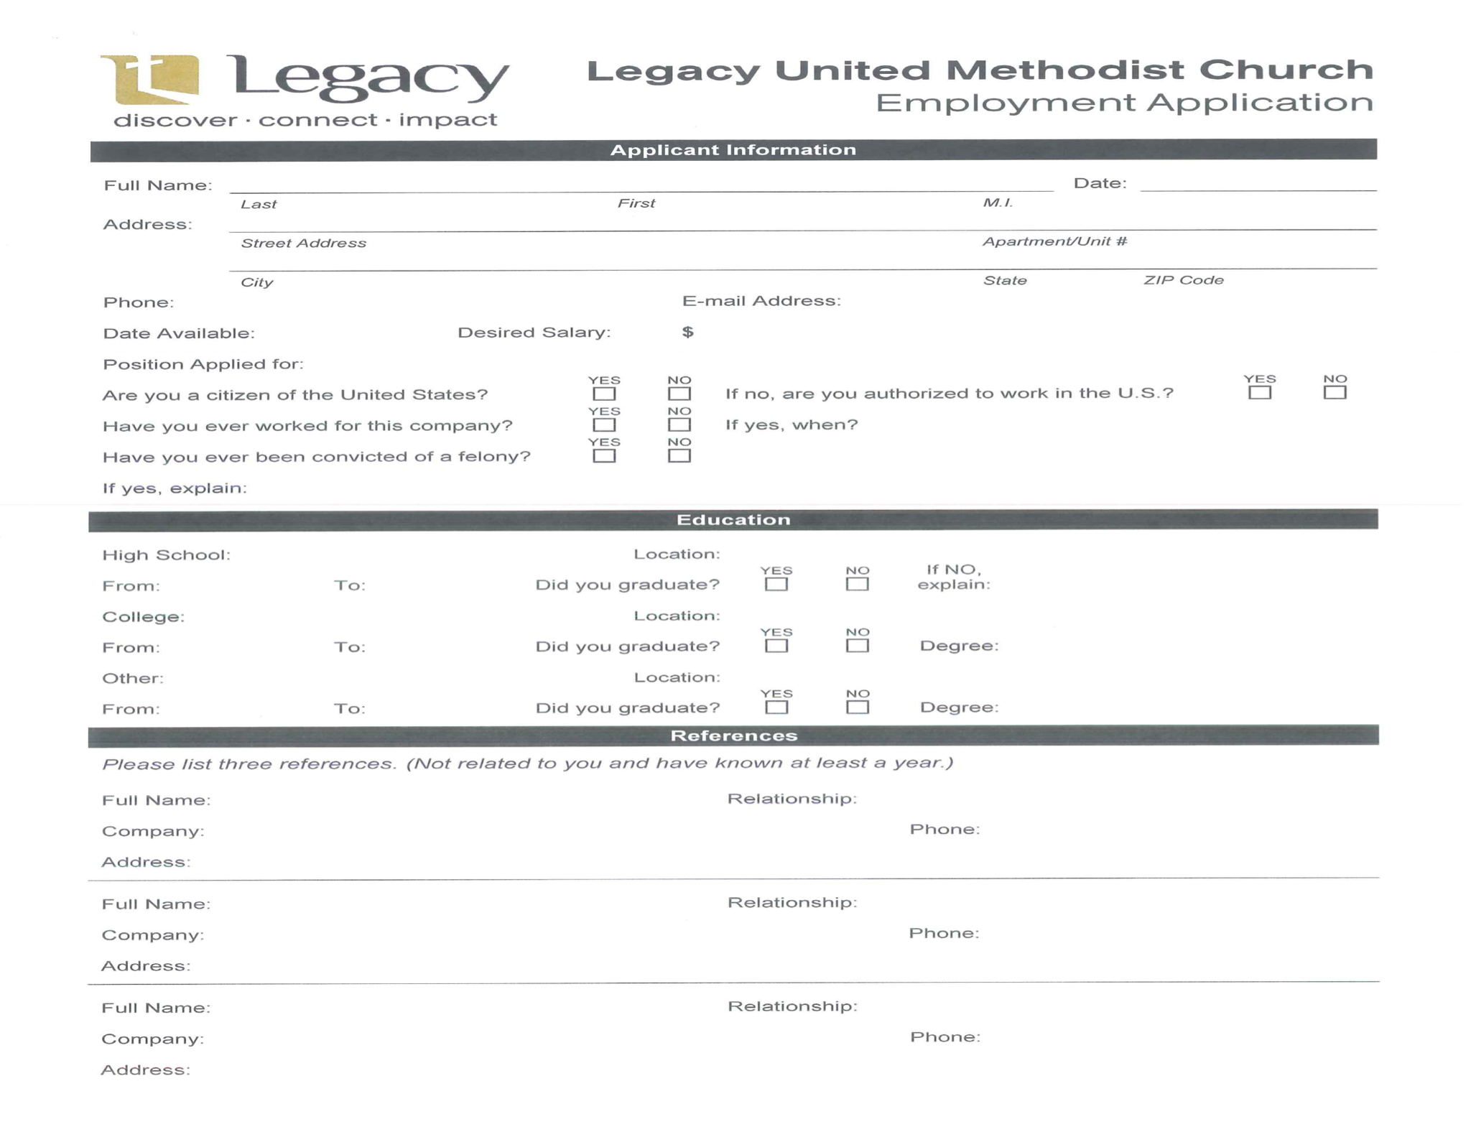

APPENDIX D
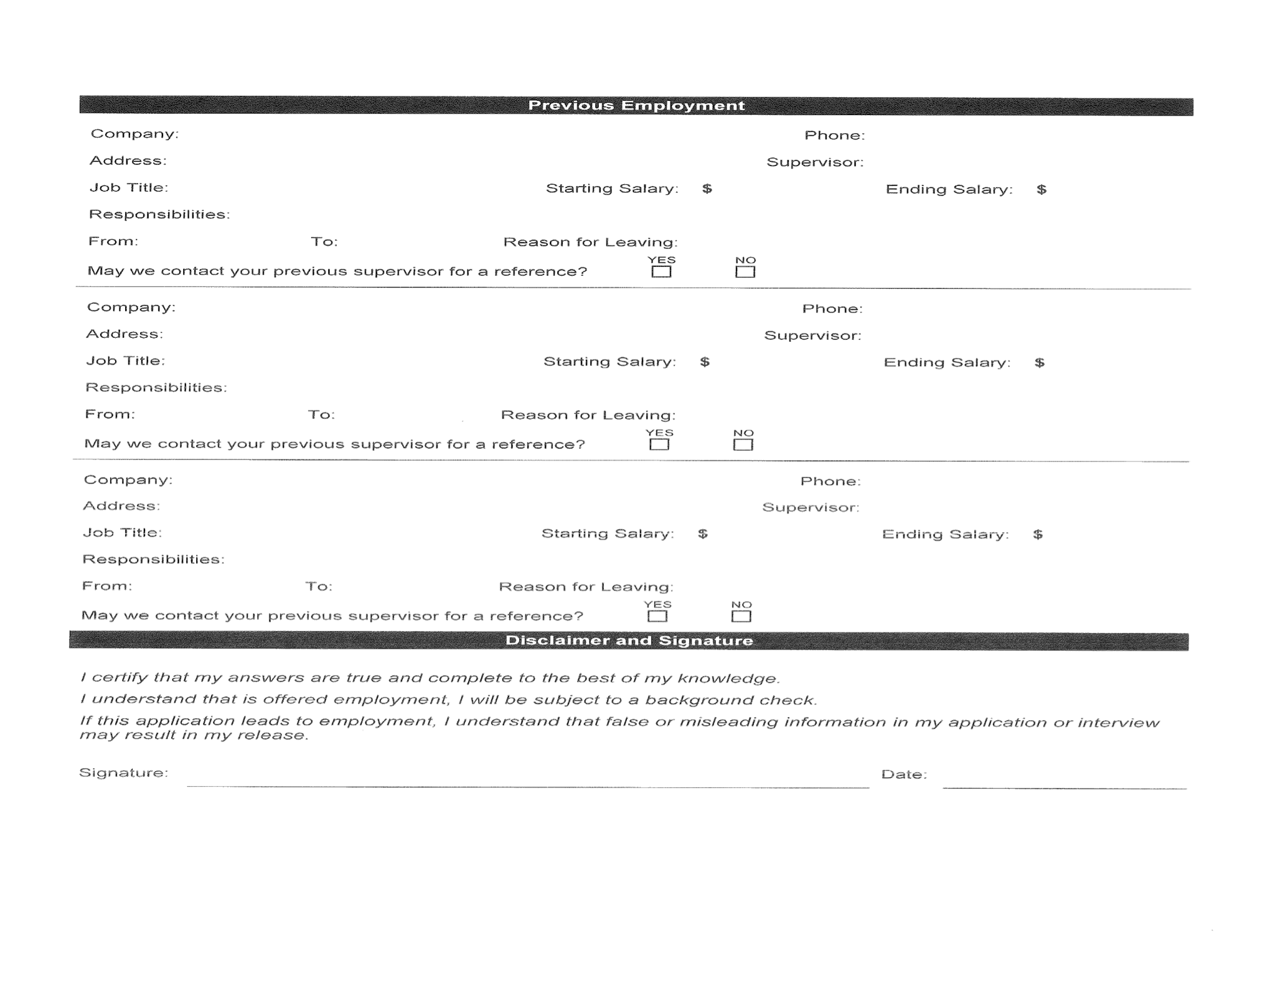

APPENDIX E
LEGACY UNITED METHODIST CHURCH
EMPLOYEE MONTHLY TIMESHEET
 | EMPLOYEE ______________________ |  |  |  | MONTH __________________________
 | HOURS | LEAVE TAKEN |  |  |  | TOTAL
DATE | WORKED | ANNUAL | SICK | HOLIDAY | BANK | HOURS | COMMENTS
1
2
3
4
5
6
7
8
9
10
11
12
13
14
15
16
17
18
19
20
21
22
23
24
25
26
27
28
29
30
31
TOTAL

